INTRODUCTION :-

“**WATER is a non-conventional source of energy**”, keeping this in mind, we present HOLD THE GRIP, Based on the principle of PASCAL’S LAW ,a mechanism which cleans a dump yard without the use of conventional sources. A Hydraulic drive system is a transmission system that uses pressurized hydraulic fluid to power hydraulic machinery. It helps reduce pollution and makes our environment greener.

ABOUT US :-

**URECKON** is the annual technical fest conducted by the University Of Engineering And Management,Kolkata. URECKON brings together the best and brightest minds to battle it out in various exciting and knowledge-enhancing events in the fields of engineering. **UEM tech fest** provides a perfect platform to test the well-known Laws of Hydraulics and design a syringe-actuated arm, which has the potential to move the given objects in a specified way through this **event**. The event comprises of 3/2 on spot elimination rounds (Depending on the umber of participants). This event will test both the locomotion and hydraulic movement of the arm.

RULES AND REGULATIONS :-

1. Any material from this list can be used in making the machine. Syringes, Tubes, Wood (card board), Metallic frames, Rubber bands, screws, nuts and bio-degradable waste.
2. The team should comprise of a maximum of 4 members.
3. The fluid used inside the syringes should be water only. Mixing of salts or oils in water is prohibited.

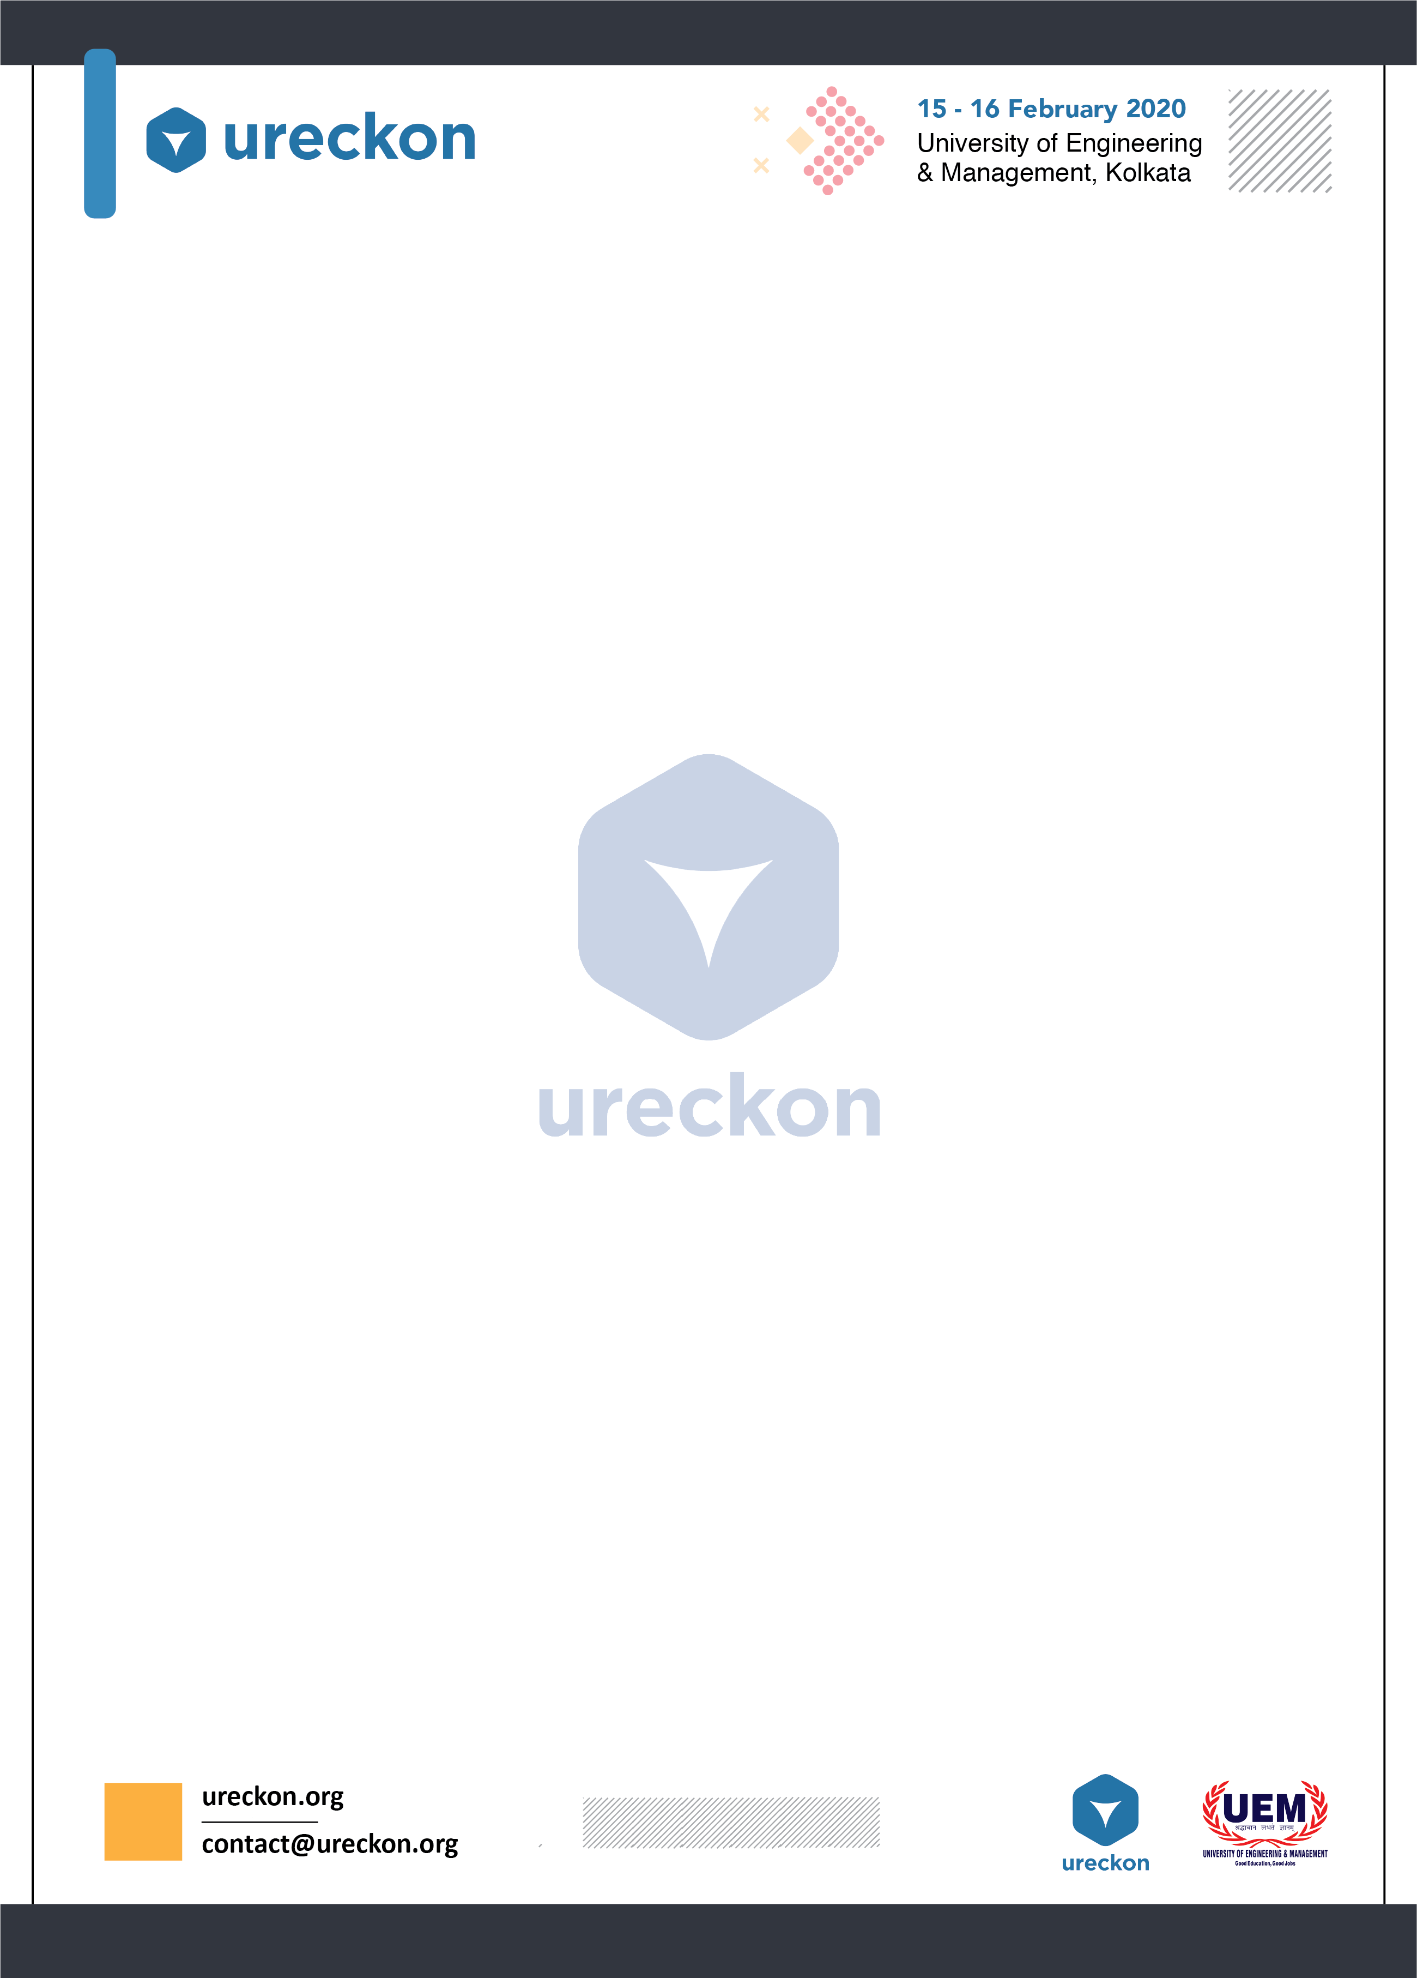



1. **In case of any discrepancy, decision of the judges shall be treated as final and binding on all.**
2. All teams must report 30 min before the event begins.
3. The organizers reserve the right to change the rules and/or arena as they deem fit.
4. When a team is called for match, they must report within five minutes.
5. The run will stop if any of these 3 occurs:
6. 3 minutes has elapsed.
7. The team says “stop”.
8. If the bot makes some damage to the arena.

BOT SPECIFICATION :-

▸ The height of the arm must not be more than 50cm.

▸ The base of the bot must not be not more than 30cm*30cm.

▸ The bot should not have any mechanism that can damage the arena in any manner.

▸ The bots shall be inspected before the event. Failing the inspection shall lead to disqualification.

▸ Only hydraulic movement mechanisms are allowed; no other mechanism can be used for the arm and jaw locomotion.

**EVENT DESCRIPTION :-**

**Event consists of two rounds.**

**First round:**  
There will be 3 box of different colour and there will be some balls of respective colours. The bot is required to pick the ball and has to keep in the box with which its colour matches. There will be 3 minutes and marks will be given on the basis of how many balls kept in the box.  
  
**Second round:**  
There will be 10 blocks.The Bot is required to arrange the blocks in a triangle form. The participants should note that successful pursuit of these objects shall be awarded higher points. Marks will be given depending on the no of triangles formed. You will get 3 minutes to form the triangle.

**NOTE:**  
1. Care should be taken to ensure that the other blocks do not fall while making the triangle. Negatives will be awarded, otherwise.  
2. While keeping the ball with in the box, the ball should not be displaced. Negatives will be awarded, otherwise.  
4. Extra points would be awarded for any team who attempt to make the arm eco-friendly and finish the task within 2 minutes.

For more details contact the co-ordinators :

1. **Ritayan Dhara** (8967343907).
2. **Somipom Mondal** (9563013090).

